Need Some Help in DS 100? I got you!

# Coding

## Function

**What:**

The best way to think of a function is to think of a mathematical function. Let’s take f(x) for instance. Let’s say we have the function f(x) = 2x+3. If I input an x-value like 3, the function will plug in the parameter 3 into the function (replacing any x’s with 3) and perform the equation, outputting 9. That’s exactly what a python function is doing. All a function is doing is taking a parameter (x) as an input and helping you find an output that might make your life easier.

**How:**

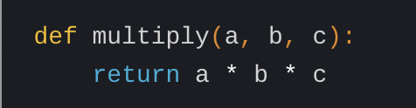

* When we create a function we will always start by defining the function (def), naming the function (add_numbers) and will sometimes put in a parameter (think of it like a variable, a and b).
* After you do the following you can then type in what you want the function to do like maybe you want it to print “hello world” or maybe you want it to add some numbers. When we write functions we generally will use RETURN, the print function however can be used for when we want to print out a message as a string.

**When:**

We use functions when we often have to rewrite lines of code. They help us make less mistakes in our code when the equations become complex, and help make code easier to read and understand.

**Links:**

* Goes through what a function is and gives you two examples of what you could use a function for (~10 min) - <https://www.youtube.com/watch?v=89cGQjB5R4M&ab_channel=BroCode>
* This example of a BMI calculator might help you understand how we use functions a little better (~14 min) - <https://www.youtube.com/watch?v=NSbOtYzIQI0&ab_channel=CSDojo>

## Apply

**What:** The apply function allows us to apply a method to a whole table. It allows us to manipulate data and will be applied to each element. You can either use the apply function on a specific column or a whole table.

**How:**

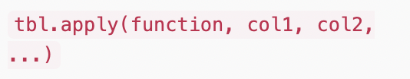

* To utilize the apply function we want to call the table we want to apply the function and then within () we specify what type of function we want to apply and what columns we want to apply it to.

**When:**

We would want to use .apply if we want to manipulate the data. It especially makes it easy to apply a function to elements in a table or column.

## Pivot

**What:** Pivot tables allow us to summarize and reorganize selected columns and rows of a table so that it makes data easier to read and understand. All a pivot table is doing is pivoting or turning the data in a new way so that we can view it from a new perspective

**How:**

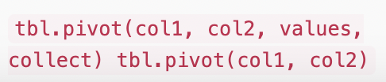

* To use a pivot table we will call the columns that we want to call, the first column you put will be the index or the rows. The second column we call will become the column names and if you want you can put in the values u want to be displayed for the those columns and the final parameter can be used to input a function like np.mean
* If you just want the count you wouldn’t need to specify the values.
* Ex. Let's say we have a table called “sales'' with columns called"date ","product ", and “revenue”. Let’s say I want to pivot this table to make it easier to understand the revenue for each product for a given date and I want to find the mean of them. I would write sales.pivot(“date”, “product”, “revenue”, np.mean)

**When:**

You might want to use a pivot table if you want a better way to read data that might be in a very difficult or long format. It also helps show specific data that you might only need to look at.

## Group

**What:**

Basically will group unique values in a given column. Let’s say we have a column called “Flavors” and it only has “Chocolate” or “Vanilla”, if we apply the group function on the columns “Flavors” it will count how many times “Chocolate” appears and how many times “Vanilla” appears in a neat little table.

**How:**

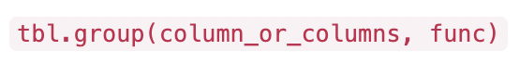

* To utilize the group function we will call the table we want within the () we will list the column or columns that we want to group by and then state the function we want to apply to them such as np.average or a function you might have created on your own. This will then apply the function to the items in the columns that we grouped.

NOTE: if you use a function that might need a certain parameter, you DO NOT need to place the given parameter when using the group function because it will take care of it.

**When:**

You might want to use this if you want to perform some sort of statistical analysis or summary, or if you only want to know something about a specific column or columns.

## For loops

**What:** A for loop is a way for us to iterate through elements in an array.

**How:**

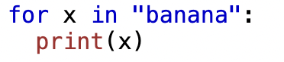

* To utilize a for loop we always begin with for, then a variable (x in this case), in, and then whatever we want to iterate through. Within the for loop we can specify what we want to do to each element in our string or array. In this case we want to iterate through each of the letters in the word “banana” and print it out.

**When:**

We might want to manipulate every single item in an array and we can do that through a for loop. We might also use a for loop if we want to check an array for something like a specific number or word

**Links:**

* Khan Academy does a great job of breaking down a for loop, especially if you are still feeling a little uncomfortable with for loops (~10 min) - <https://www.youtube.com/watch?v=9LgyKiq_hU0&ab_channel=KhanAcademy>
* This video gives a lot of different examples that might give you a better understanding (~5 min) - <https://www.youtube.com/watch?v=KWgYha0clzw&ab_channel=BroCode>

# Useful Websites/Links

* Data 8 is what DS100 is based off of and there are many videos like reviews that might be a good addition to what we are learning in class - <https://www.youtube.com/@Data8Berkeley>

# List of Topics That Need to Be Covered

Please add a topic to the list that you might want resources for :)